操作系统：Debian 11 x64 (bullseye)

1、关闭防火墙：

root@web-01:~# sudo ufw disable

Firewall stopped and disabled on system startup

root@web-01:~# iptables -L -n

安装x-ui

root@web-01:~#bash <(curl -Ls https://raw.githubusercontent.com/vaxilu/x-ui/master/install.sh)

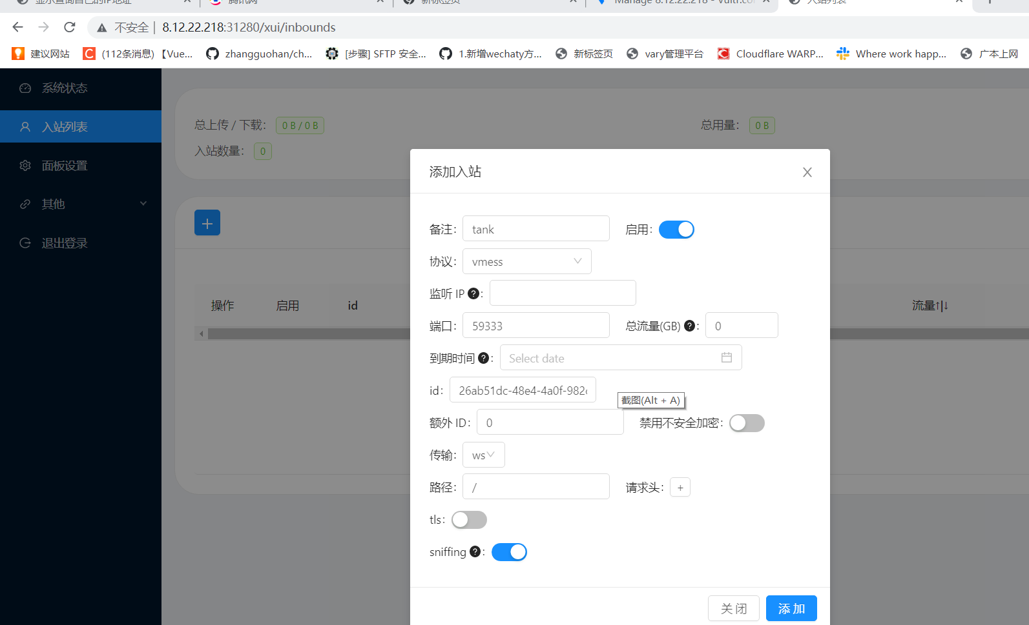

bash <(curl -fsSL git.io/warp.sh) d

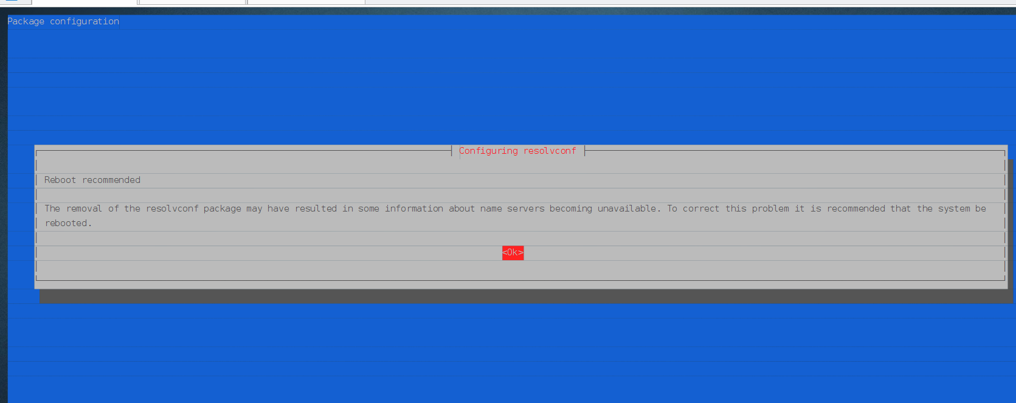

重启后再次执行：

bash <(curl -fsSL git.io/warp.sh) d

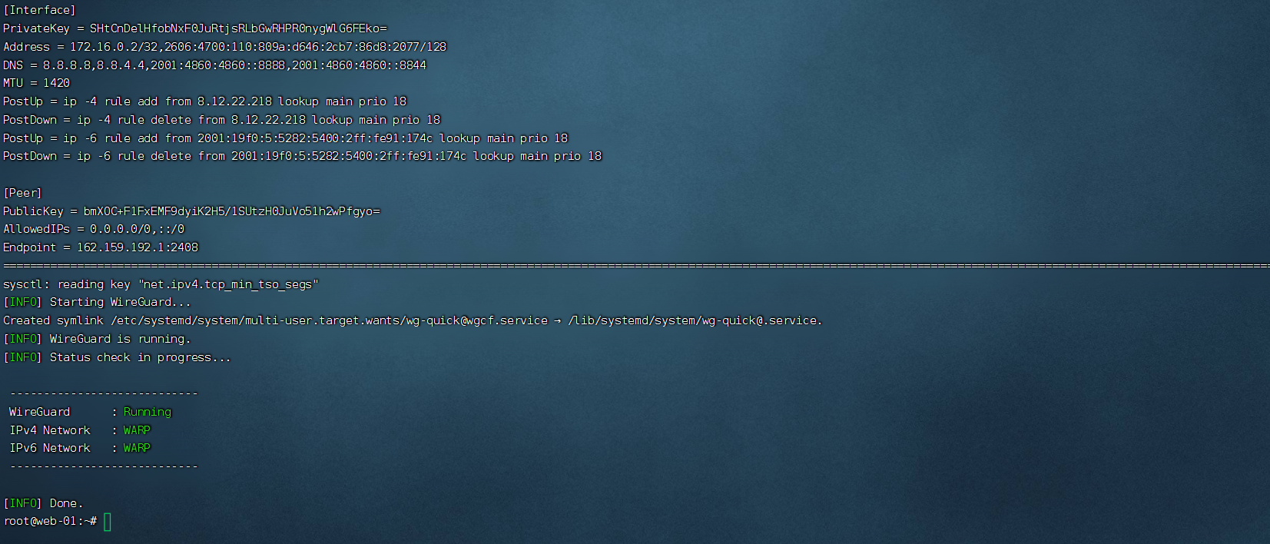

systemctl enable [wg-quick@.service](mailto:wg-quick@.service)

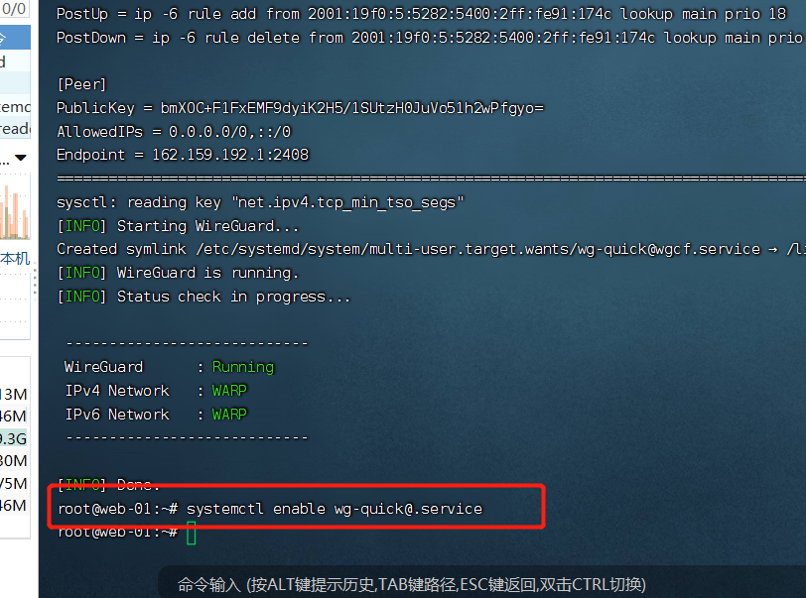

测试是否使用：

bash <(curl -Ls <https://cdn.jsdelivr.net/gh/missuo/OpenAI-Checker/openai.sh>)

详细步骤如下 ：

1 sudo ufw disable

2 iptables -L -n

3 bash <(curl -Ls https://raw.githubusercontent.com/vaxilu/x-ui/master/install.sh)

4 bash <(curl -Ls https://cdn.jsdelivr.net/gh/missuo/OpenAI-Checker/openai.sh)

5 bash <(curl -fsSL git.io/warp.sh) d

6 reboot

9 ping www.qq.com

10 ifconfig

11 bash <(curl -fsSL git.io/warp.sh) d

12 systemctl enable wg-quick@.service

13 reboot

14 ping www.qq.com

15 ifconfig

16 top

17 ps -ef

22 ifconfig

23 history